Project: Deploying java application on k8s cluster using Argocd

Steps:
- Launch 2 instance for master(t2 large) for working node (t2.meidum)
- Install docker , maven , sonarqube Jenkins, k8s on master node
- Access Jenkins and configure sonarqube
- Install argocd on master node and access it
- Create an application on argocd and establish sync
- Run the Jenkins pipeline

Launch instance and install docker, maven,Jenkins
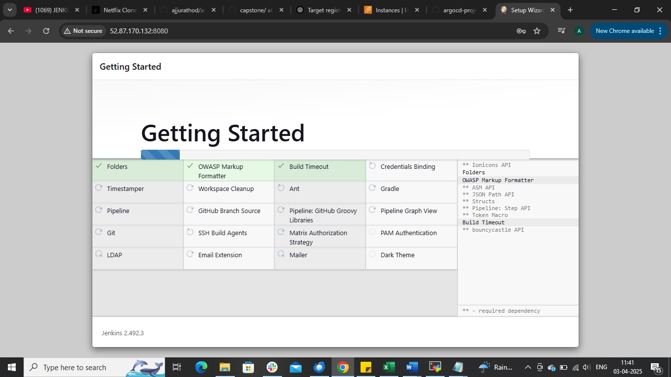

Install sonarqube using docker commad
docker run -td –name sonar-cont -p 9000:9000 sonarqube:latest

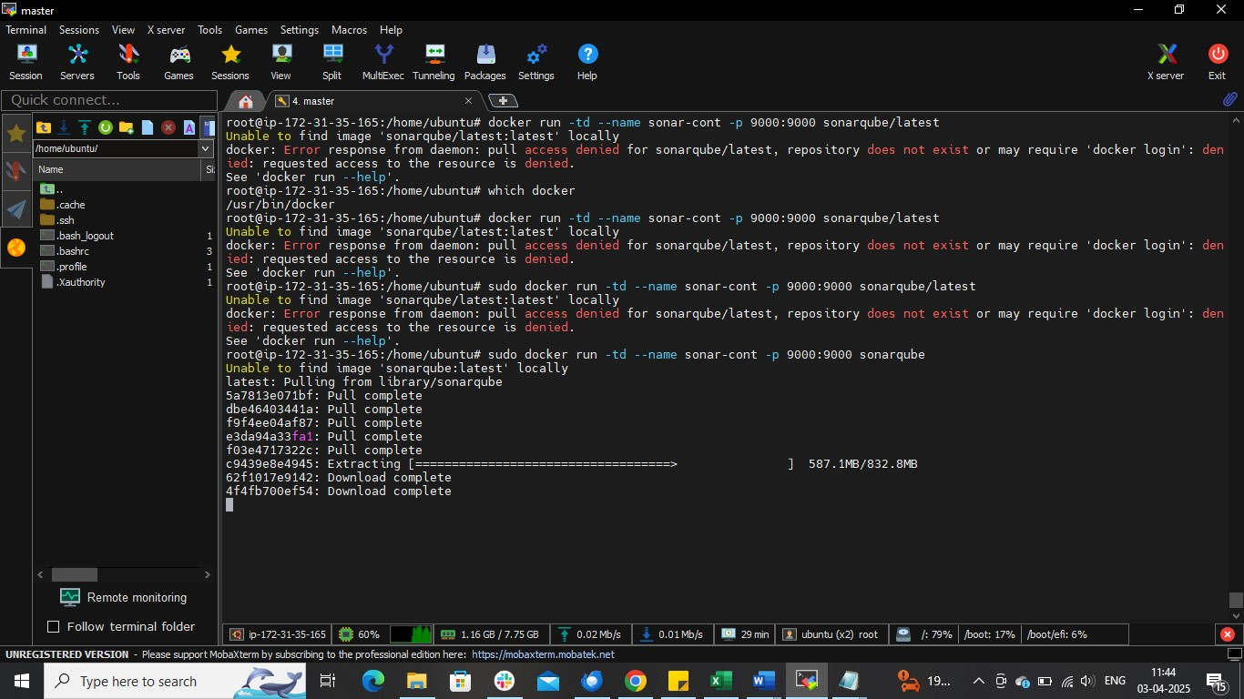

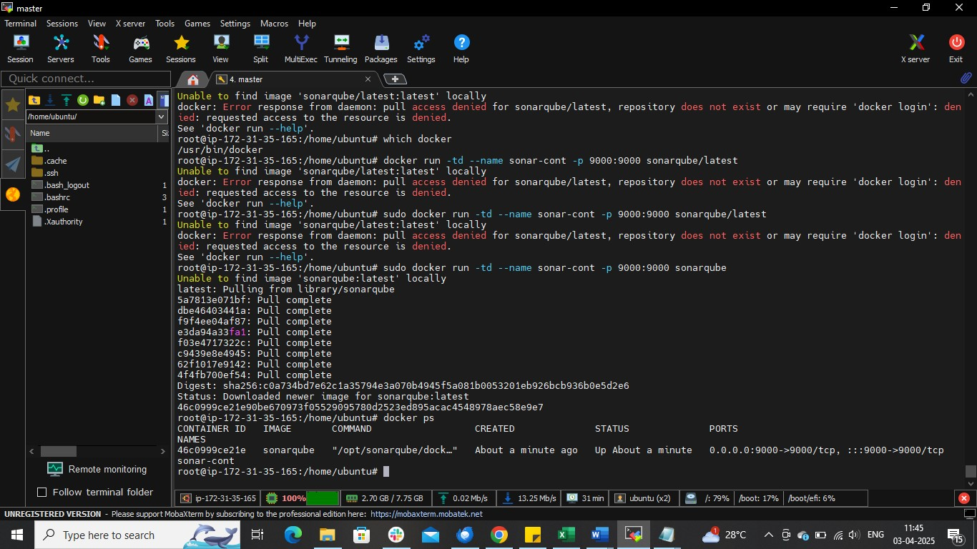
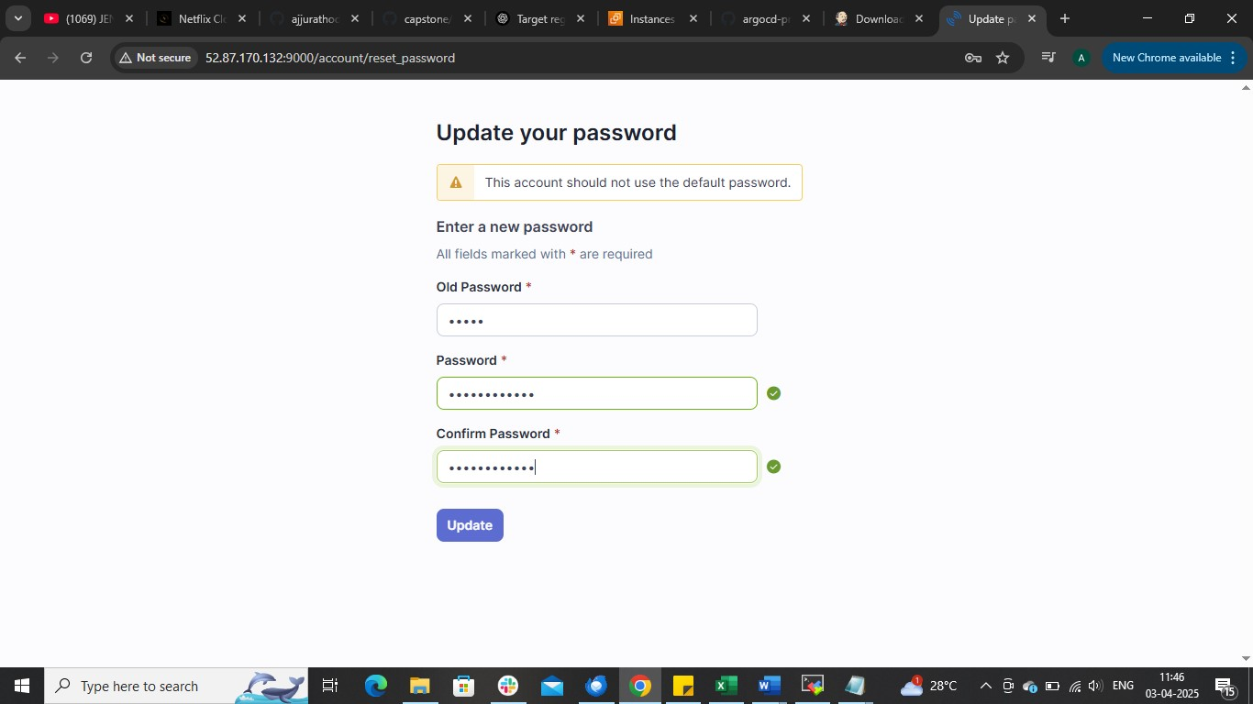
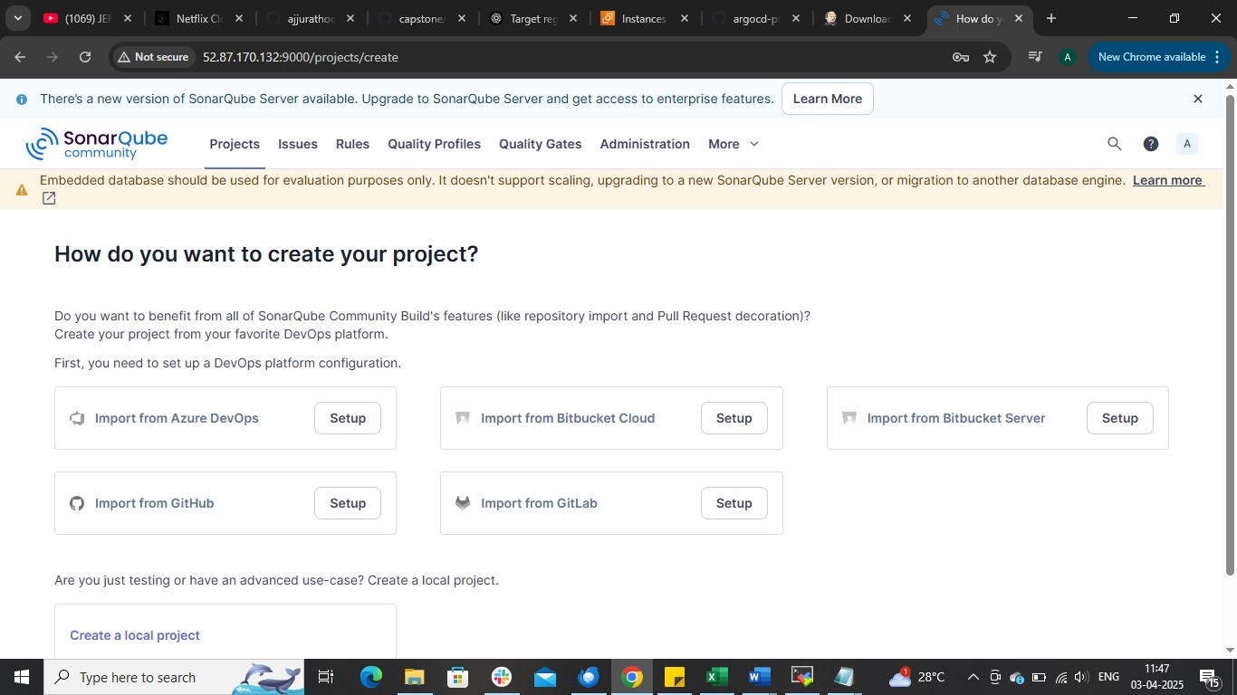

On Jenkins install plugins
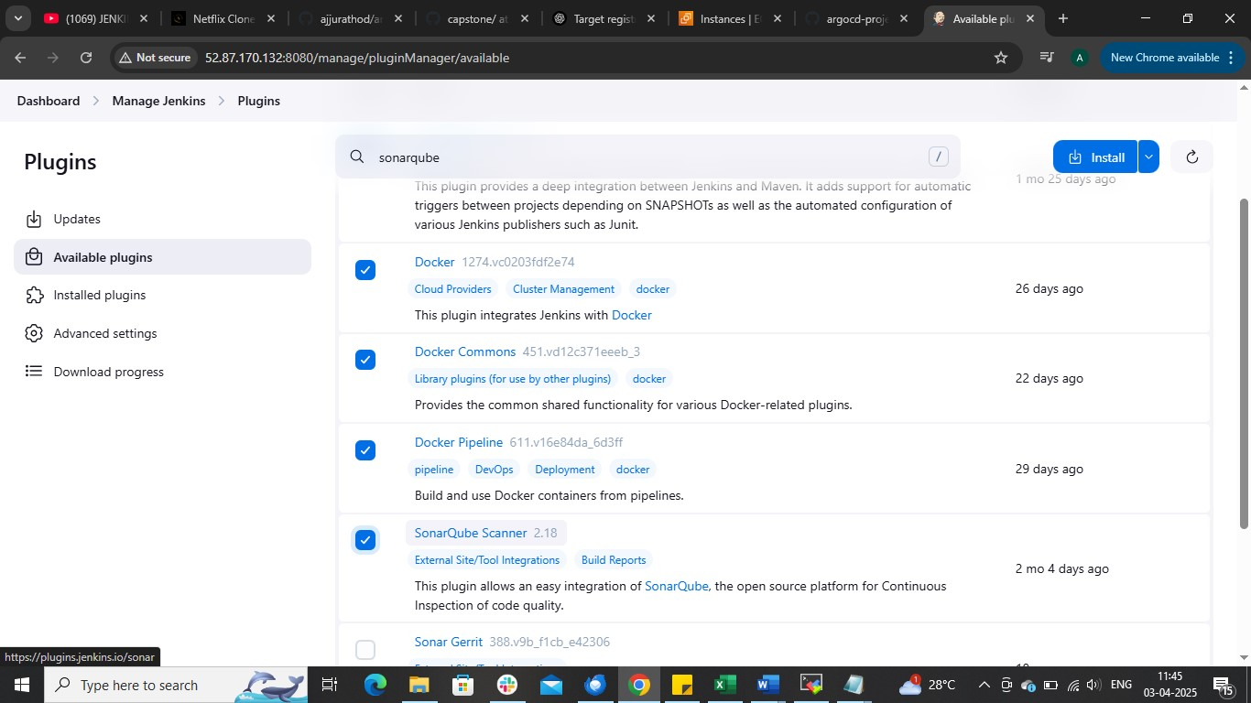

manage jenkinstools
And the tools docker, maben sonarqube
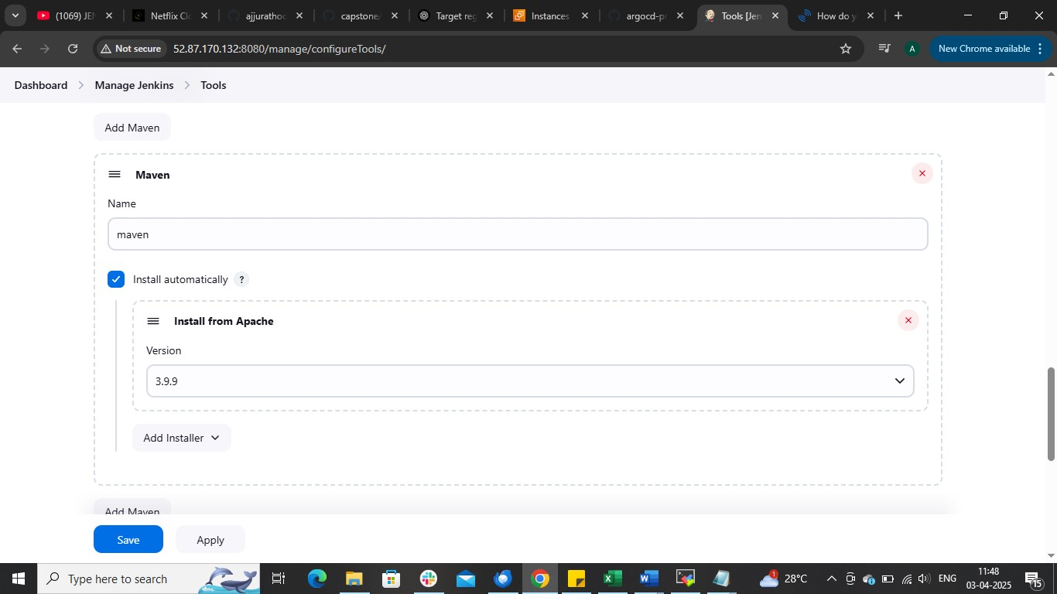

Go to the sonarqube server
administratorsecurityusertokencreate token
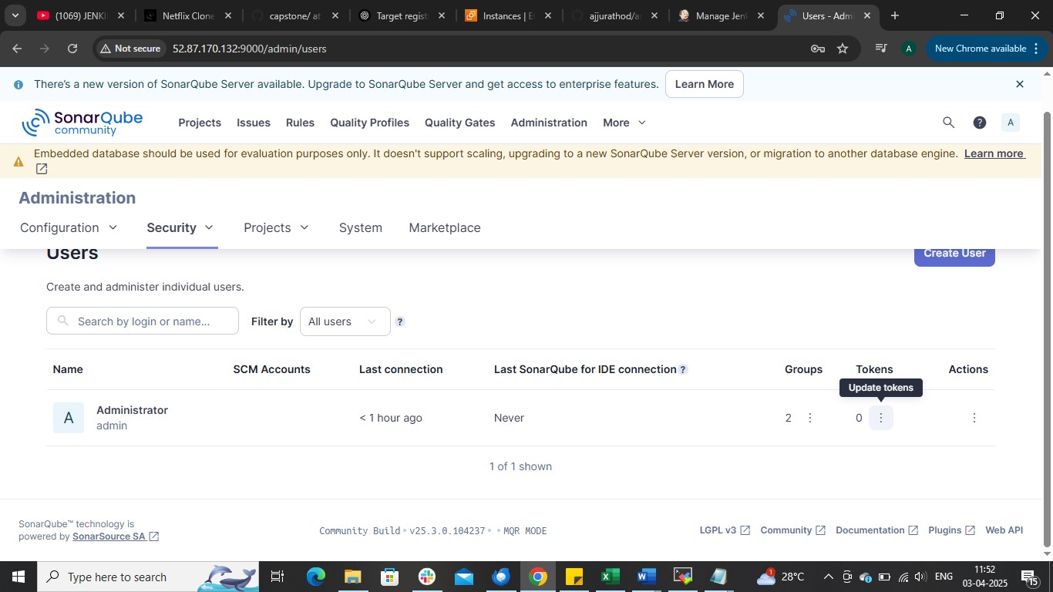

Copy the token
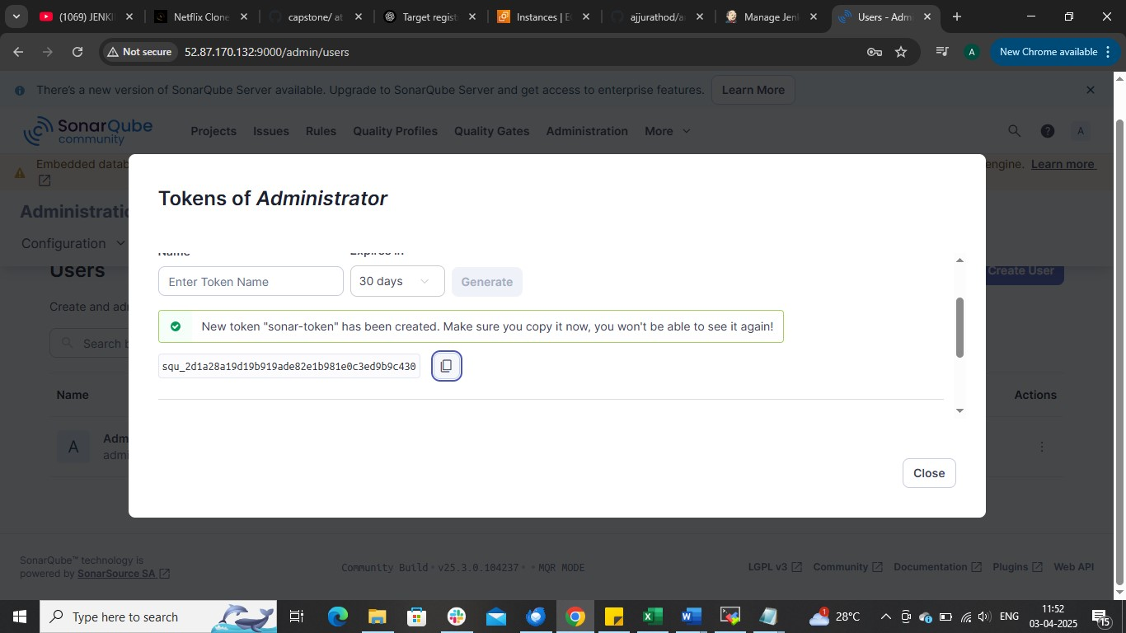

manage Jenkins(MJ)credentials
Store credentilas as secreat text
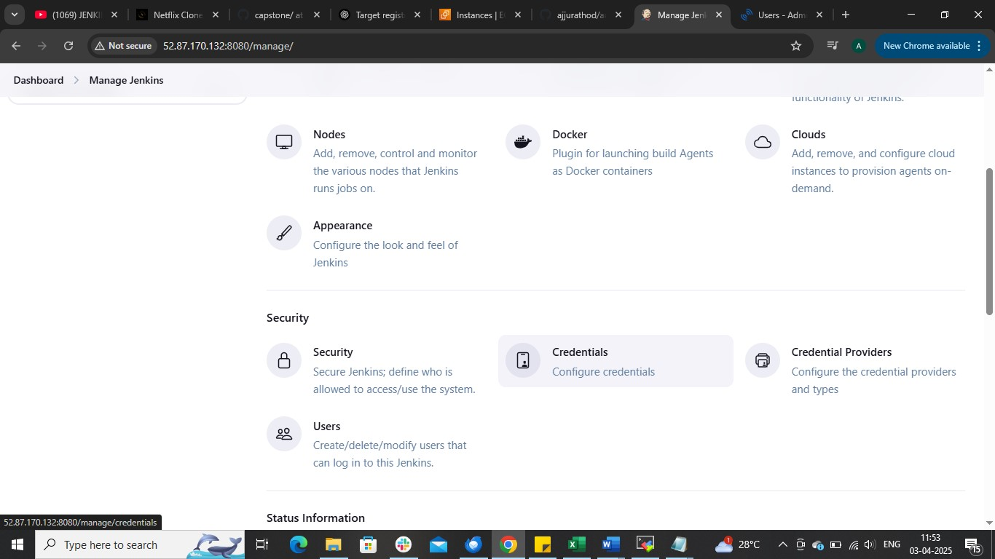

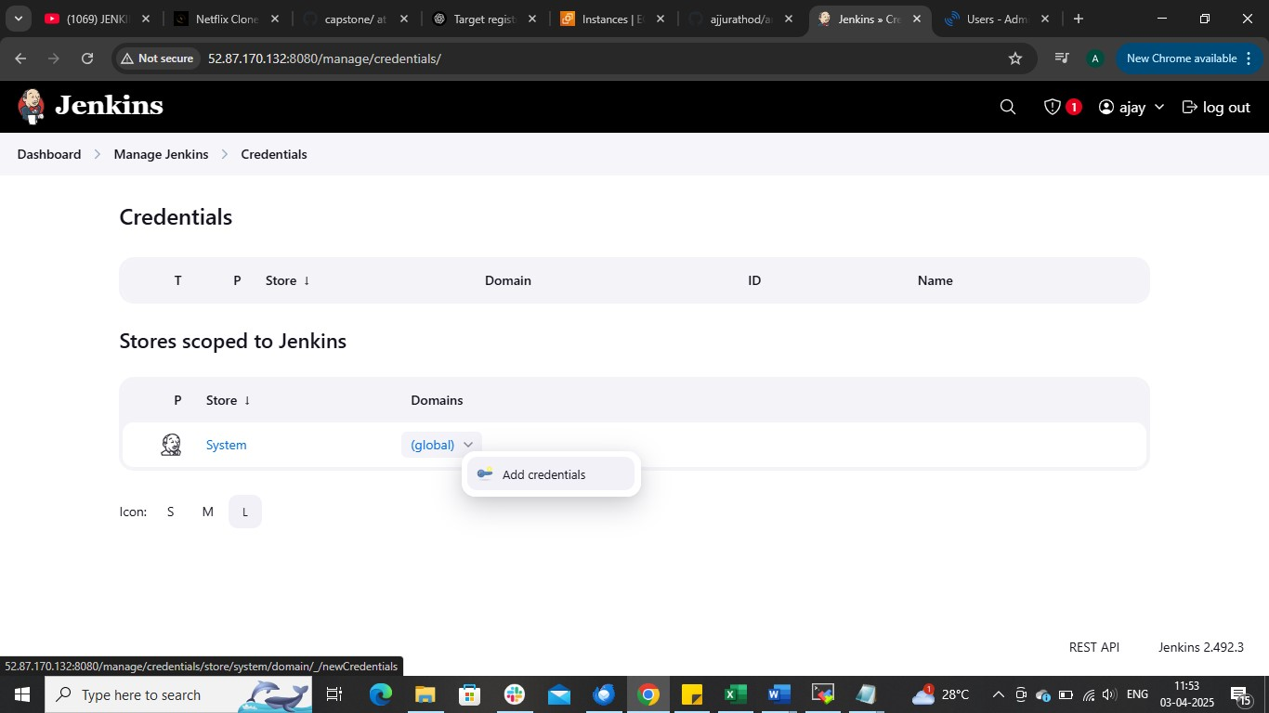
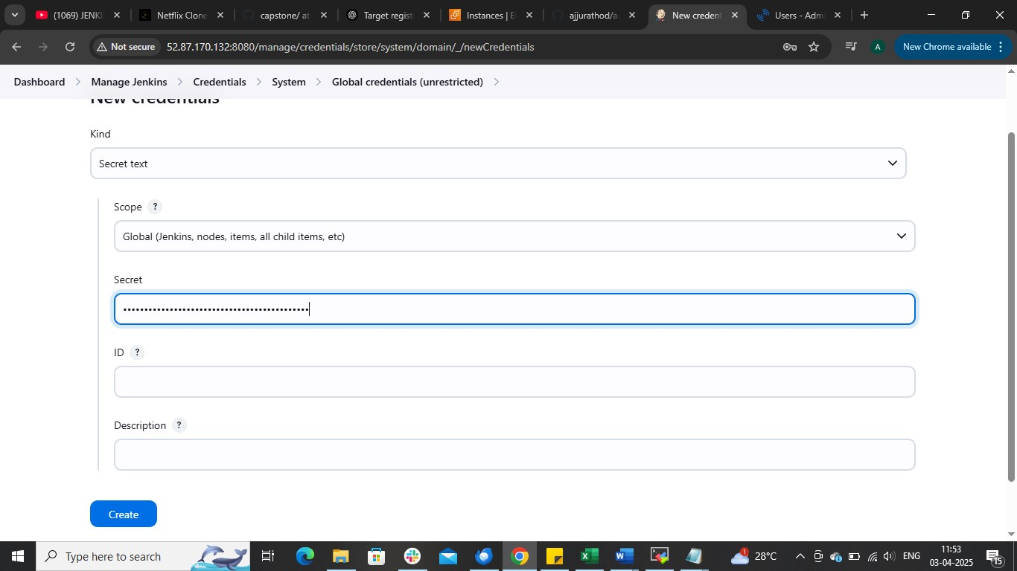

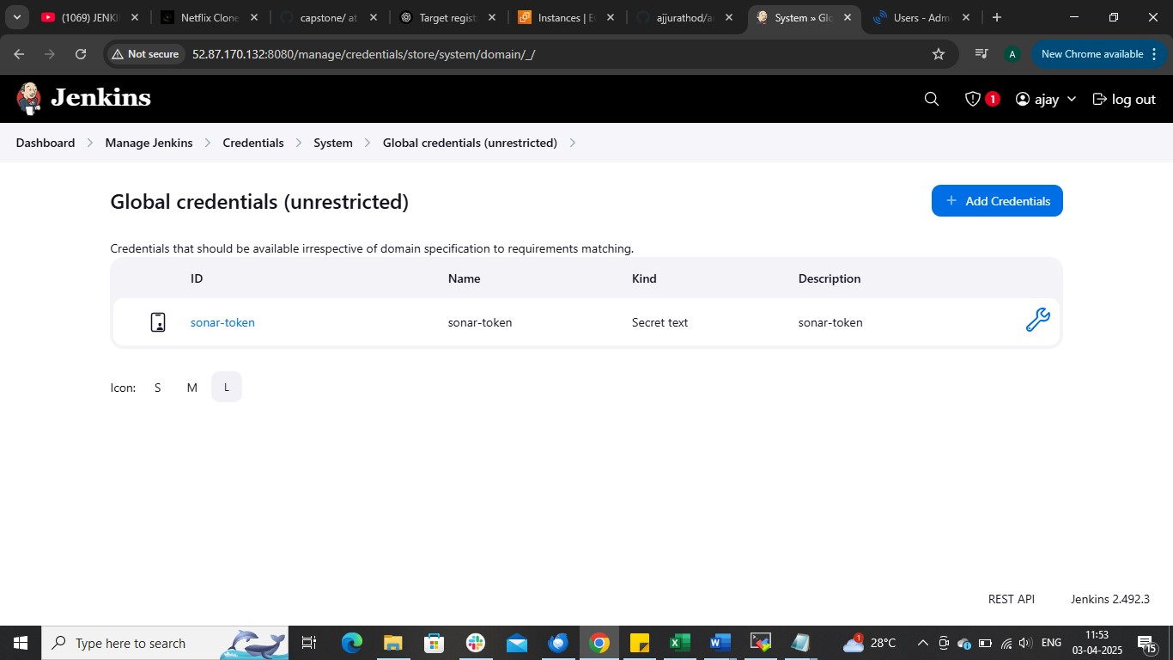

MJsystem
And the sonarqube server path
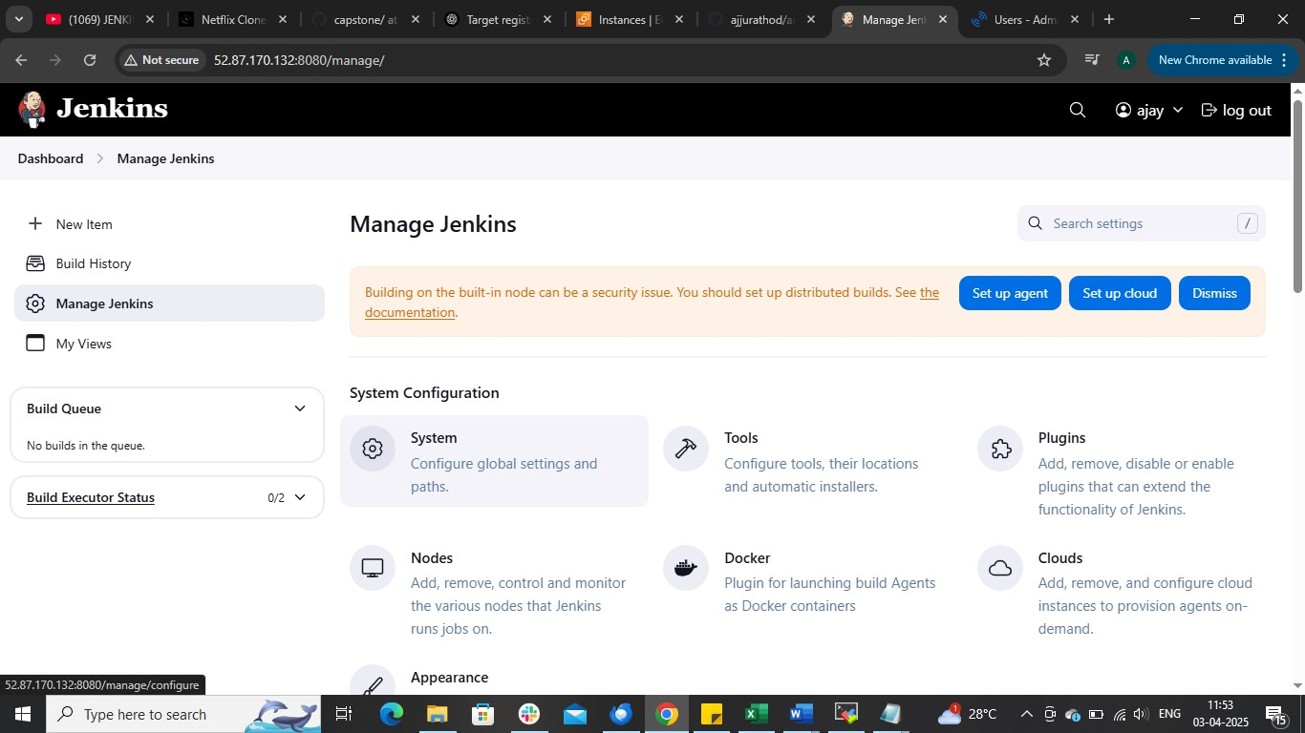

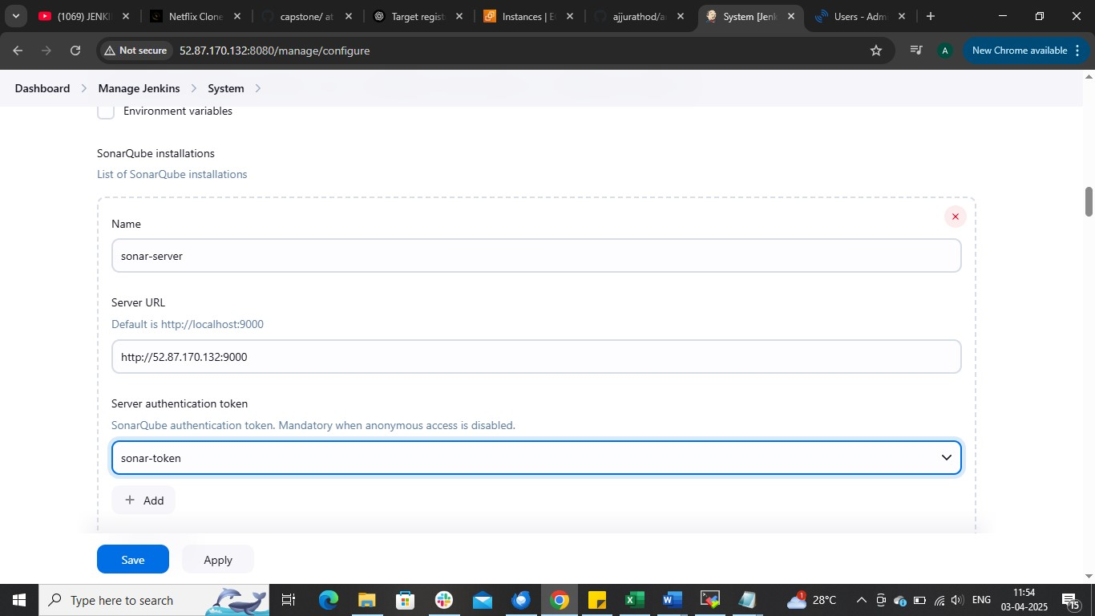

Now Install k8s cluster and configure worker node
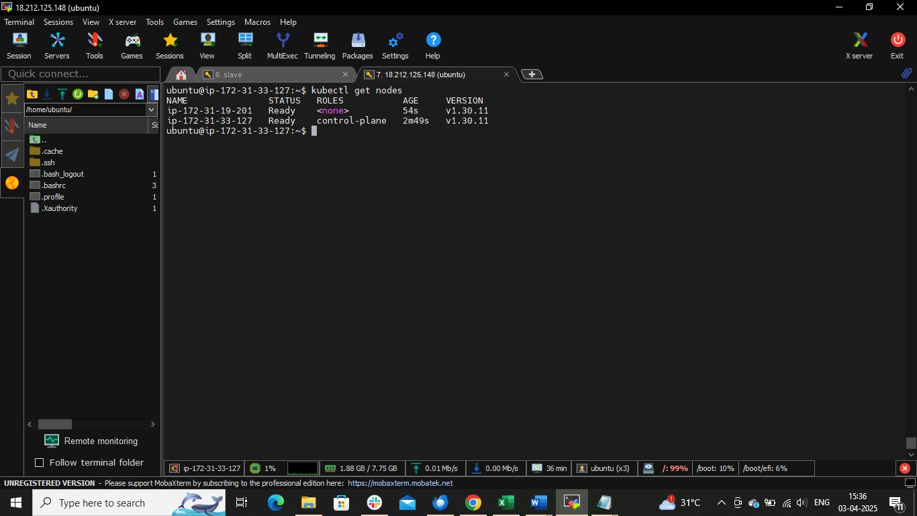

And install argocd on master node
kubectl create namespace argocd
kubectl apply -n argocd -f https://raw.githubusercontent.com/argoproj/argo-cd/stable/manifests/install.yaml
kubectl expose svc argocd-server --name=argocd-server-np --type=NodePort --port=80 --target-port=8080 -n argocd
kubectl get svc argocd-server-np -n argocd

## to get password to login
kubectl get secret -n argocd argocd-initial-admin-secret -o jsonpath="{.data.password}" | base64 --decode

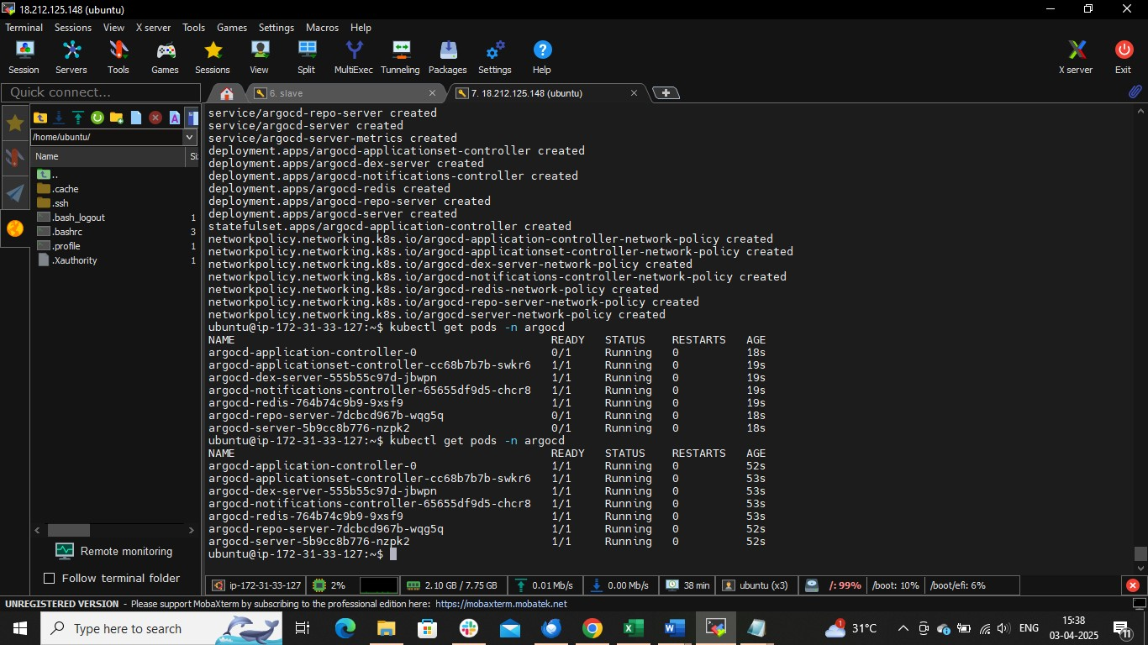

Change service from ClusterIP to NodePort to access the argo cd
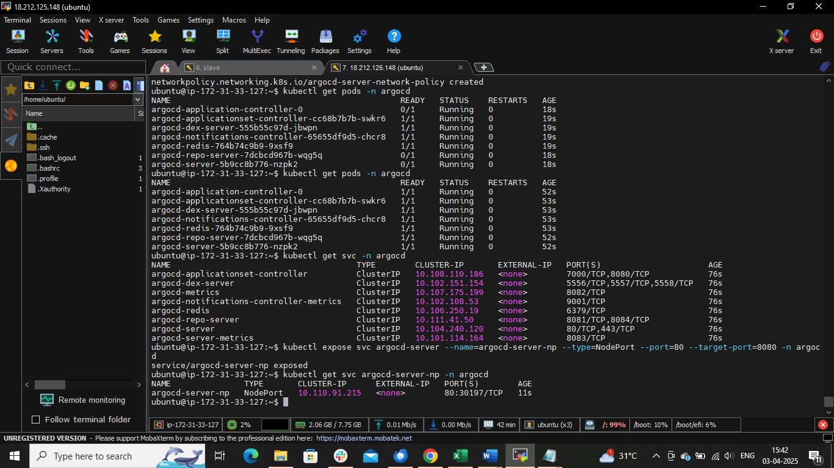

Copy publicIp of master node and nodeport
Publicip:Nodeport
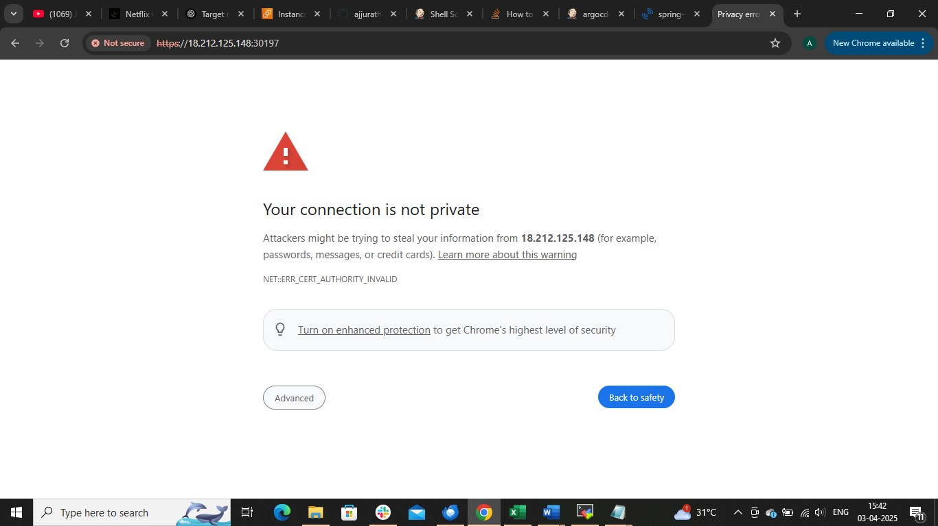

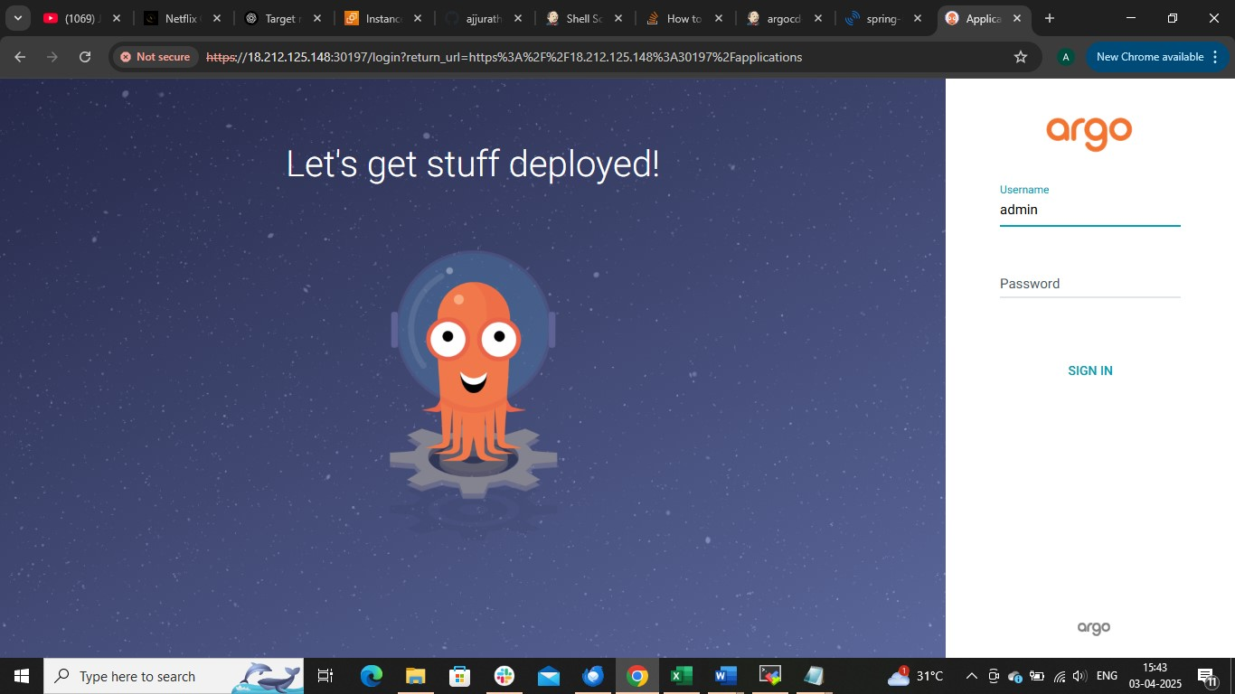

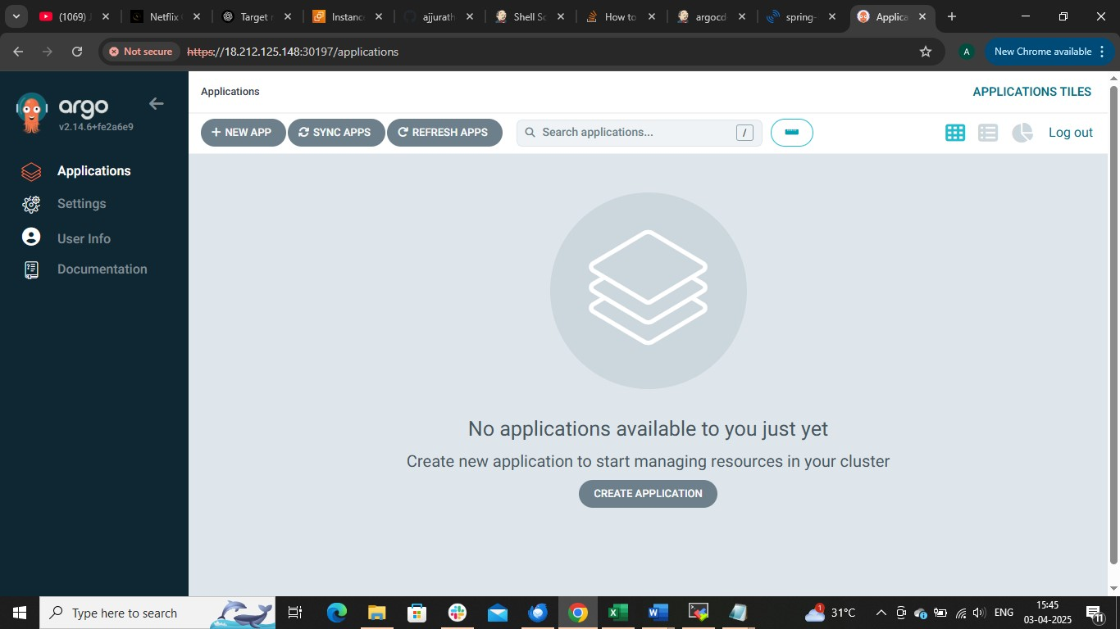

Now github credentilas as secret text in jenkins
Github username and access token
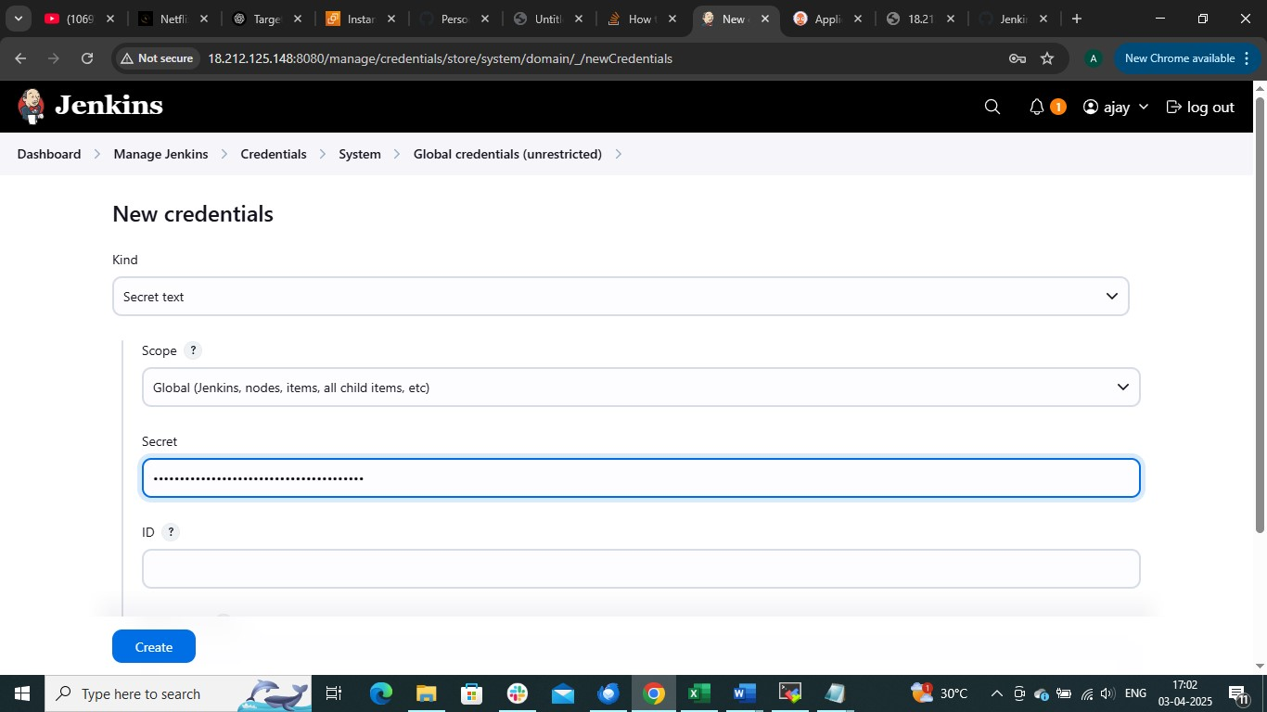

Git repo: https://github.com/ajjurathod/argocd-project-new.git
Now write a pipeline sysnatx
pipeline {
agent any

environment {
IMAGE_NAME = "ajjurathod1998/anisha"
GIT_REPO_NAME = "argocd-project-new"
GIT_USER_NAME = "ajjurathod"
DEPLOYMENT_FILE = "java-maven-sonar-argocd-helm-k8s/spring-boot-app-manifests/deployment.yml"
}

stages {
stage('Code Checkout') {
steps {
git branch: 'main', url: "https://github.com/ajjurathod/argocd-project-new.git"
}
}

stage('Build and Test') {
steps {
sh 'cd java-maven-sonar-argocd-helm-k8s/spring-boot-app && mvn clean package'

}
}

stage('Static Code Analysis') {
environment {
SONAR_URL = "http://34.201.116.83:9000"
}
steps {
withCredentials([string(credentialsId: 'sonarqube', variable: 'SONAR_AUTH_TOKEN')]) {
sh 'mvn sonar:sonar -Dsonar.login=$SONAR_AUTH_TOKEN -Dsonar.host.url=${SONAR_URL}'
}
}

stage('Build Docker Image') {
steps {
sh 'cd java-maven-sonar-argocd-helm-k8s/spring-boot-app && docker build -t ${IMAGE_NAME}:${BUILD_NUMBER} .'
}
}

stage('Push to DockerHub') {
steps {
withCredentials([usernamePassword(credentialsId: 'docker-hub', usernameVariable: 'DOCKER_USERNAME', passwordVariable: 'DOCKER_PASSWORD')]) {
sh '''
echo "$DOCKER_PASSWORD" | docker login -u "$DOCKER_USERNAME" --password-stdin
docker push ${IMAGE_NAME}:${BUILD_NUMBER}
'''
}
}
}

stage('Update Deployment File') {
steps {
withCredentials([string(credentialsId: 'github-token', variable: 'GITHUB_TOKEN')]) {
sh '''
git config user.email "ajjurathod1998@gmail.com"
git config user.name "ajjurathod"

# Replace image tag in deployment file
sed -i "s|replaceImageTag|${BUILD_NUMBER}|" ${DEPLOYMENT_FILE}

git add ${DEPLOYMENT_FILE}
git commit -m "Update deployment image to version ${BUILD_NUMBER}"
git push https://${GITHUB_TOKEN}@github.com/${GIT_USER_NAME}/${GIT_REPO_NAME} HEAD:main
'''
}
}
}
}
}

Build the job
Open sonarqube server
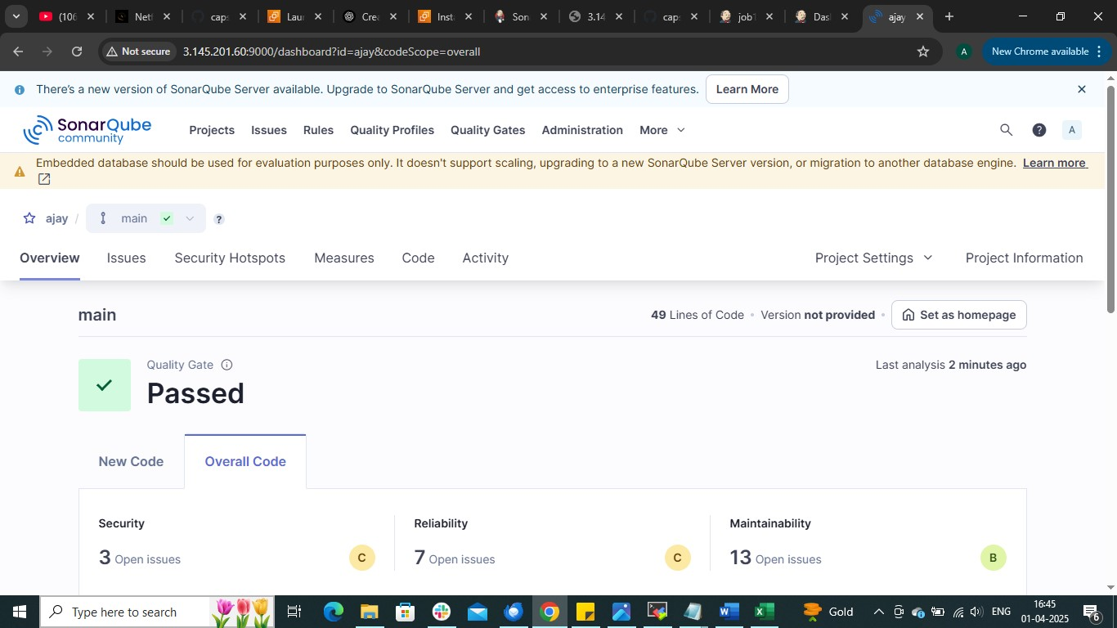

Create a application on argocd
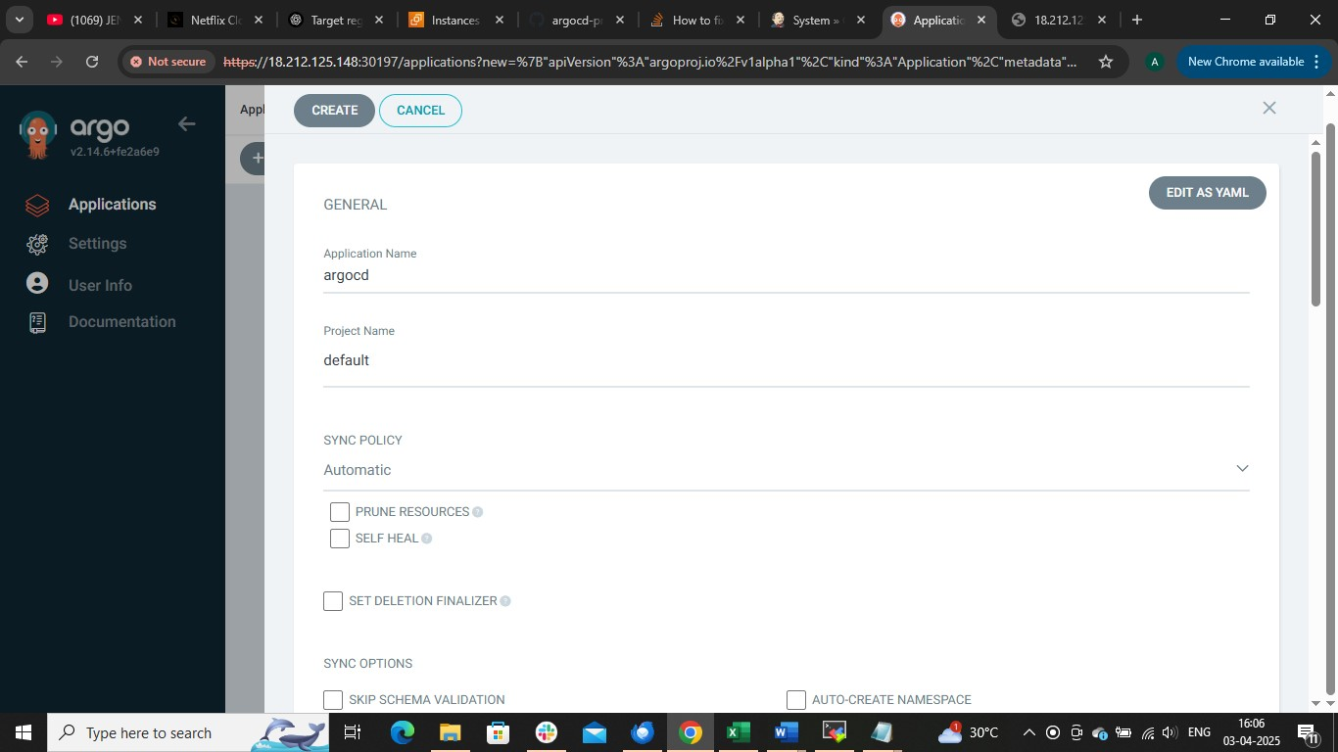

Provide source and write path of manifest file location
